Executive Summary
The North Carolina Early Childhood Action Plan (ECAP) was released in February 2019 and established goals and targets based on the current state of child health and well-being to improve early childhood outcomes by 2025. When this plan was released, we could not have known that the COVID-19 pandemic would disrupt lives across the state and nation. COVID-19 necessitated a sudden shift in how programs function and families are served. The pandemic has and will continue to have major public health implications. Further, children and families will experience ripple effects from school closures, the economic recession, extended time away from peers, and strain to the social safety net. Black and Brown families in particular have suffered greatly from COVID-19 due to structural racism and systemic oppression.
The goal of this document is to record changes to NC programs and policies that serve North Carolina families in response to the COVID-19 pandemic, identify data limitations resulting from those changes, and make recommendations about how to use ECAP data moving forward. This project aims to address the unforeseen challenges that have developed due to the COVID-19 pandemic by identifying programs are being implemented differently and changes to data that are being collected as a result of new implementation approaches.

Background
The North Carolina Early Childhood Action Plan (ECAP), which was released in 2019, establishes ten goals aimed at addressing children’s ability to live healthy lives, have safe and nurturing relationships, and learn and be ready to succeed. Each of the ten goals includes targets and sub-targets that serve as indicators of improvement as the State works towards those goals. Goals, targets, sub-targets, and measures reflect the data that were available and the expected function of early childhood service systems prior to the COVID-19 pandemic. The pandemic has disrupted nearly all aspects of those service systems. Therefore, it is important to consider how service systems and data collection changed beginning in March 2020 so we can measure changes in each target and sub-target and make recommendations about how goals may need to shift or be re-prioritized in light of the pandemic.

Current Considerations
We reviewed each indicator in the ECAP and identified concerns about data quality based on our knowledge in July 2020 about how programs and policies have changed thus far. The summary table is color coded to indicate levels of concern over data reliability and validity due to changes in data collection, reporting, or practice in response to COVID-19. Reliability means that data are consistent across time. Validity means that the data are actually measuring the factor(s) they are intended to.
- Low data quality (red) indicates a measure that relies on data we anticipate will be unreliable and potentially invalid due to data collection and reporting changes or due to unknown procedural implications from COVID-19.
- Moderate data quality (yellow) indicates a measure that relies on data we anticipate is reliable but may be affected by currently unknown sources of bias. Data may have uncertain validity.
- High data quality (green) indicates a measure that relies on data we anticipate is reliable and valid and do not have reason to believe that there will be changes in data quality due to COVID-19 related barriers.
We do not recommend eliminating any data sources at this time despite some questions regarding data reliability and validity. It is reasonable to expect to see changes in trends for nearly all indicators beginning in March 2020 due to widespread policy and practice changes. By maintaining all original data sources and indicating where data may be unreliable or invalid, we can better identify whether there were actual changes in key indicators or whether some variance during the COVID-19 period may be due to data quality. We also recommend adding new data sources to some targets in cases where we believe the current data source may not be designed to capture nuanced variation.
We also rate the priority of each target for achieving ECAP goals in 2025 based on current predictions of the level of vulnerability and impacts of the COVID-19 pandemic on the existing ECAP measures.
- High priority (red) means that efforts to meet a target need to increase substantially to overcome deficits that may by imposed by the COVID-19 pandemic or that efforts to meet a target are prioritized because they will have secondary effects on other targets.
- Moderate priority (yellow) means that efforts to meet a target may need to increase but that we do not anticipate downstream impacts due to the COVID-19 pandemic.
- Low priority (green) means that the indicator is still important but that we do not anticipate needing to increase existing efforts to meet targets once programs re-open.

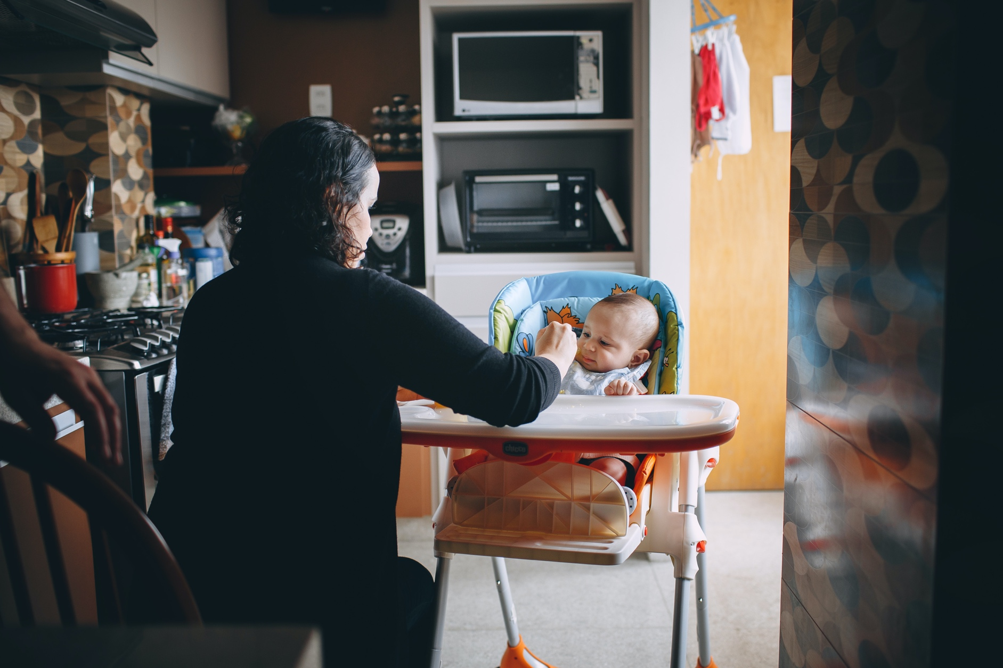
Goal 3: Food Security
ECAP Commitment: Babies, toddlers, young children, and their families across North Carolina will have access to enough healthy food every day.
COVID-19 and Possible Impacts on Goal 3 Indicators:
- COVID-19 placed strain on the food market early in the pandemic, limiting access to staple foods. Many families have experienced loss of income to COVID-19 job loss or reductions in employment hours which may increase food insecurity.
- The number of WIC income-eligible families may increase as a result of COVID-19 economic impacts.
- A number of factors may limit children’s food access. However, changes in food access may not be reflected in the data as the current food access indicator is a measure of proximity to grocery stores or other food sources. These data do not reflect families’ ability to purchase food or the amount of food in the home available to children.
- Weight and body composition assessments may not be possible through telehealth. There may be gaps in data.

Indicator | Data Quality Considerations | Vulnerability
Rate of Children 0-17 Years who are Food Insecure  Current Data Source: Feeding America | High – Food insecurity is measured at the state and county level using publicly available state and local data from the U.S. Census Bureau and Bureau of Labor Statistics on factors that research has shown to contribute to food insecurity. These factors include unemployment  and poverty as well as other socioeconomic and demographic characteristics. Beginning in 2020, the estimates also account for disability status. We do not anticipate that data quality will change in response to COVID-19. | High – Food insecurity among children may increase due to changes to school breakfast and lunch programs. These changes may not be reflected in the existing data source. Food insecurity may have downstream effects on other indicators, including the percent of children who are overweight or obese.
Percent of Eligible Families in North Carolina Receiving State and Federal Supplemental Food/Nutrition Assistance Benefits from WIC  Current Data Sources: NC Women, Infants, and Children (WIC) Program, Nutrition Services Branch, Division of Public Health, NCDHHS | High – Estimates of the population eligible for WIC services are calculated by estimating the number of individuals at risk using the following data sources: 1) Number of live births, 2) Number of fetal deaths, 3) Population 0-4 years of age, 4) Percent of population with income less than 185% of poverty. We do not anticipate that data quality will change in response to COVID-19. | High – The number of eligible families may increase and the capacity of WIC offices may decrease in the short-term in response to COVID-19. Federal guidelines waived some barriers to enrolling in WIC in light of COVID-19. Enrollment in WIC may have downstream effects on other indicators.
Percent of Children 0-17 Years Who Have Low Access to Healthy Food  Current Data Sources: U.S. Department of Agriculture | Moderate – Low access to healthy food is defined as living more than ½ mile (urban areas) or more than 10 miles (rural areas) from the nearest supermarket, supercenter, or large grocery store. This measure relies on GIS data and therefore we do not anticipate that the data quality will change in response to COVID-19; however, this measure may not accurately reflect food access as food supply chains may be impacted by COVID-19. | High – Low access to healthy food among children may increase due to changes to school breakfast and lunch programs. These changes may not be reflected in the existing data source. Low access to health food may have downstream effects on other indicators, including the percent of children who are overweight or obese.
Percent of Children in North Carolina Aged 2-4 Years Who Receive WIC and Who Are Classified as Either Overweight or Obese  Current Data Sources: NC Women, Infants, and Children (WIC) Program, Nutrition Services Branch, Division of Public Health, NCDHHS | Low – Measures of overweight and obesity are dependent on BMI, which is an anthropometric measure. NC was granted a waiver lifting requirements for anthropometric measures for WIC recipients through May 31, 2020. Therefore, we anticipate not having a reliable source of data for the number of children who are overweight or obese from mid-March through May 2020. Some data may be available through NC Care 360. | Moderate – Children’s access to healthy foods and physical activities may be limited due to COVID-19, which may increase the risk of overweight or obesity in young children who receive WIC.
Percent of Families with Children Aged 0-8 Living at or Below 200% Federal Poverty Level  Current Data Sources: American Community Survey, U.S. Census Bureau | High – Data are drawn from the American Community Survey and U.S. Census Bureau. We do not anticipate that data quality will change in response to COVID-19. | High – We anticipate that economic impacts from the COVID-19 pandemic will increase the percent of families with young children living at or below the FPL. Poverty is an upstream indicator that increases risk for many other ECAP targets.

