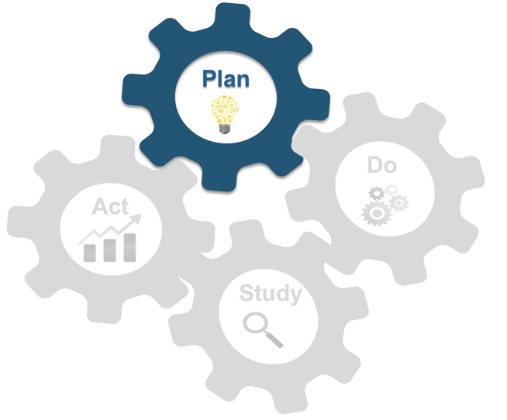
PLAN
PLAN | Aim | Ideas | Measures
 | What are we trying to test, change, or accomplish? | What change will we make to get this improvement? | What will we measure to monitor change or improvement?
 |  | Where?
 | Why is this important? | When? | How often?
 |  | With Whom? | Where?
 | What is the goal for success or improvement? | Does this align with the goal for success or improvement? | From Whom?
 |  | Is this feasible? Doable? | Will this tell us if we have met our goal for success or improvement?

 | Tasks Generated during Planning |  | Who is responsible? | Where? | When? | Why is this needed?
DO 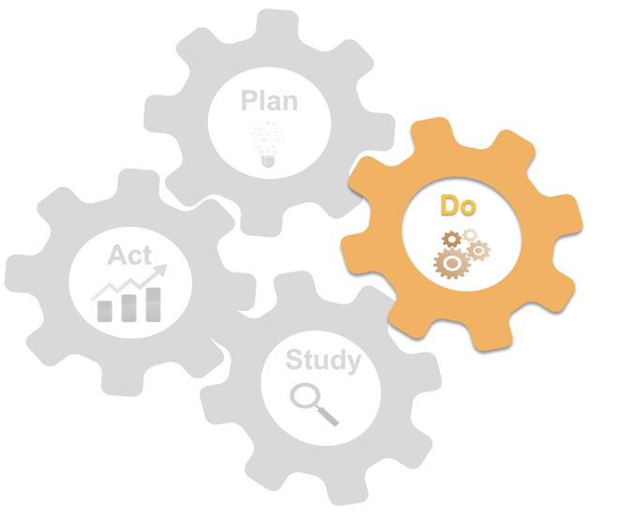
DO | Any unexpected observations or problems noted during this phase?
STUDY 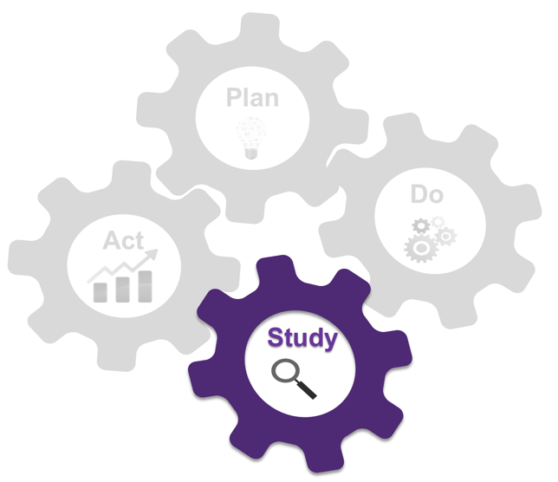
STUDY | Describe Data Collected:
 | Compare to Goal:
 | Learnings from Study Phase:
ACT 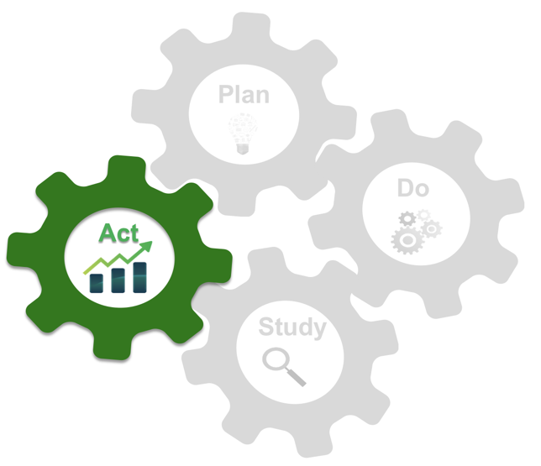
ACT | How will you apply what you learned?  Adaptions:  Adoptions:
 | Tasks Generated during Act Phase |  | Who is responsible? | Where? | When? | Why is this needed?

